**EC2 Instance Setup Lab**

I launched, resized, managed, and monitored an Amazon EC2 instance in this lab, gaining a basic overview of EC2 operations.

In this lab, I gained hands‑on experience with Amazon EC2 by completing the following tasks:

- I launched a web server with termination protection enabled.

- I monitored my EC2 instance.

- I modified the security group to allow HTTP access.

- I resized my Amazon EC2 instance to scale.

- I tested termination protection.

- I terminated my EC2 instance.

Task: Launch and Manage an EC2 Instance with Termination Protection

Steps I Took:

1. Launched EC2 Instance

- I went to the EC2 Dashboard and clicked Launch instance.

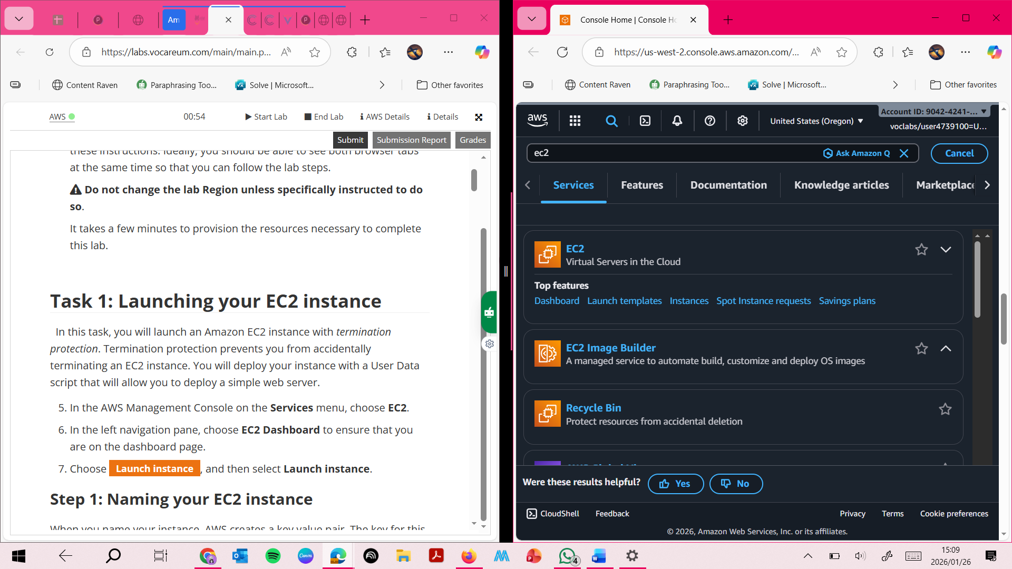

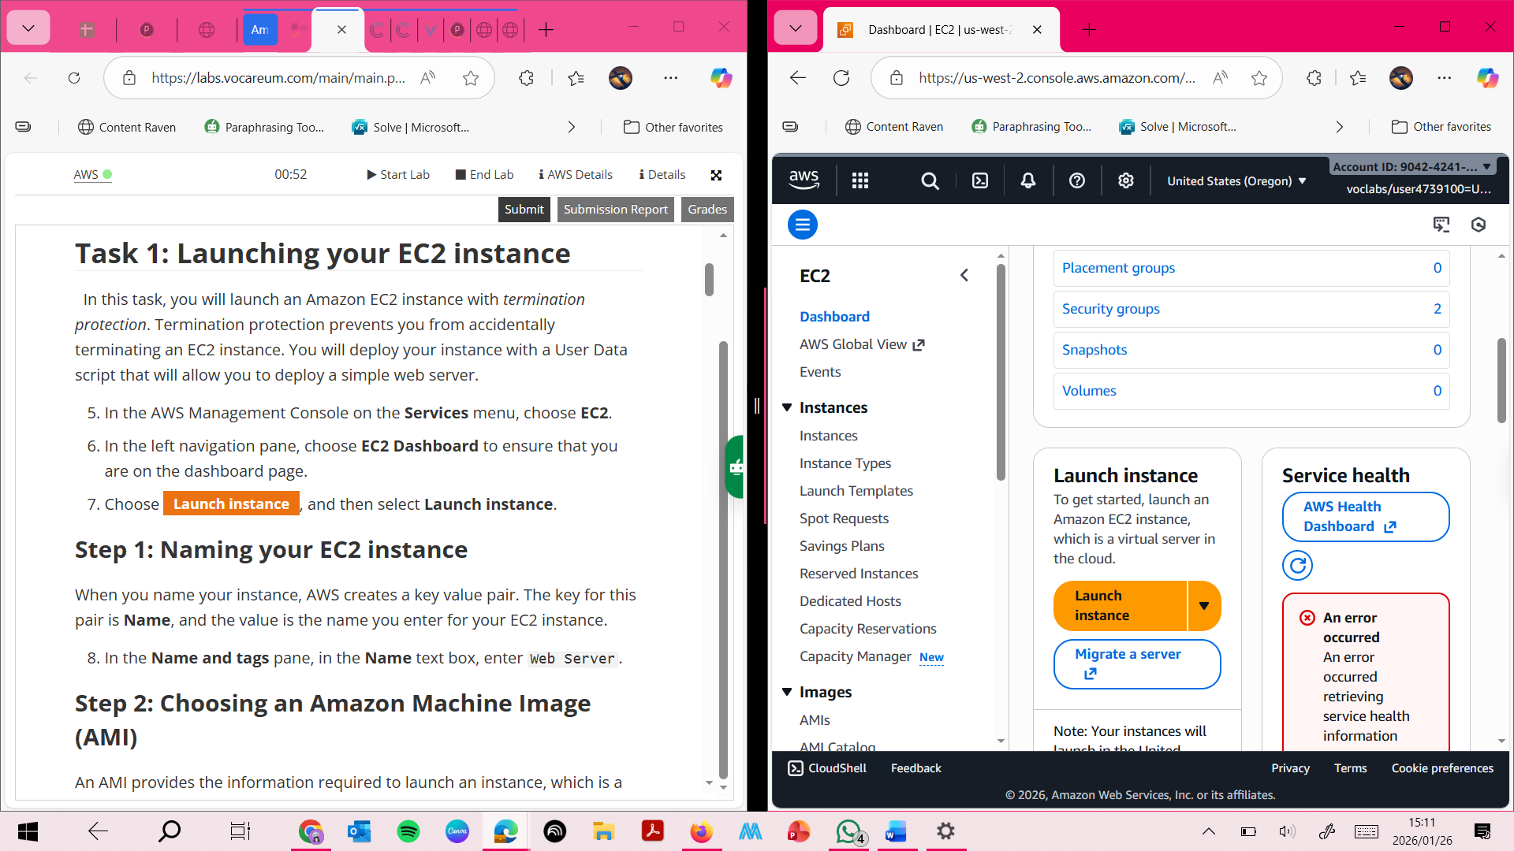

In the left navigation pane, I chose **EC2 Dashboard**

Choose **Launch instance**, and then select **Launch instance**.

**Step 1: Naming your EC2 instance**

When you name your instance, AWS creates a key value pair. The key for this pair is **Name**, and the value is the name you enter for your EC2 instance.

1. In the **Name and tags** pane, in the **Name** text box, enter Web Server.

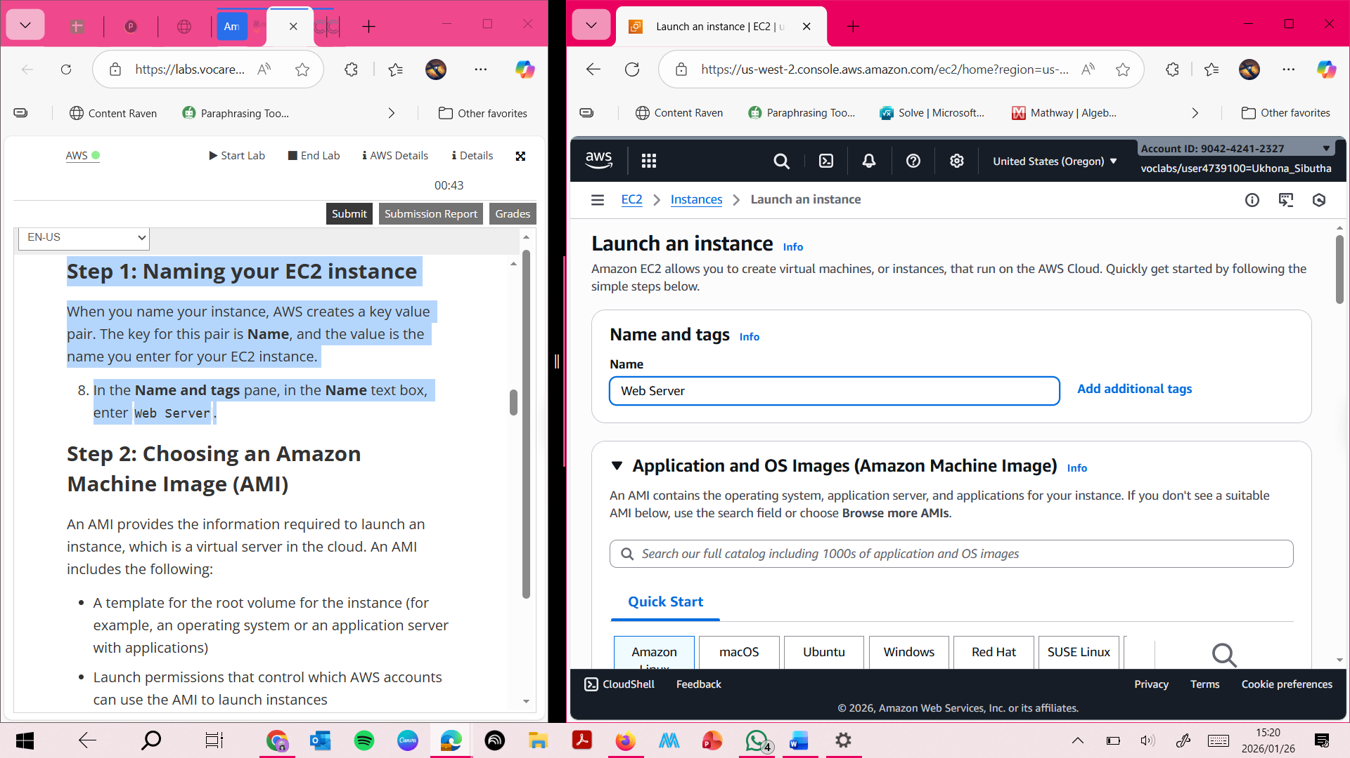

**Step 2: Choosing an Amazon Machine Image (AMI)**

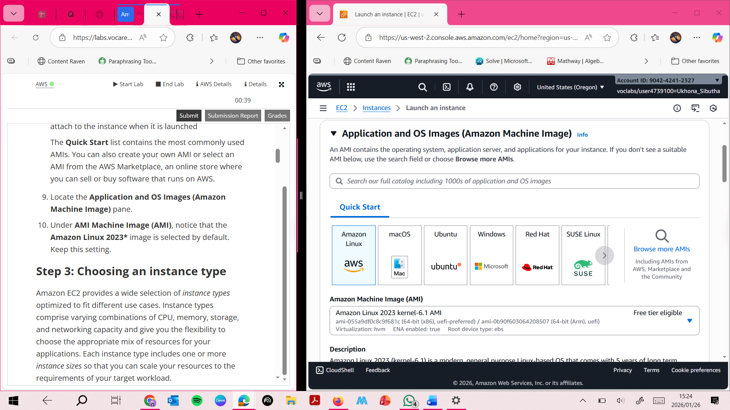

**Step 3: Choosing an instance type**

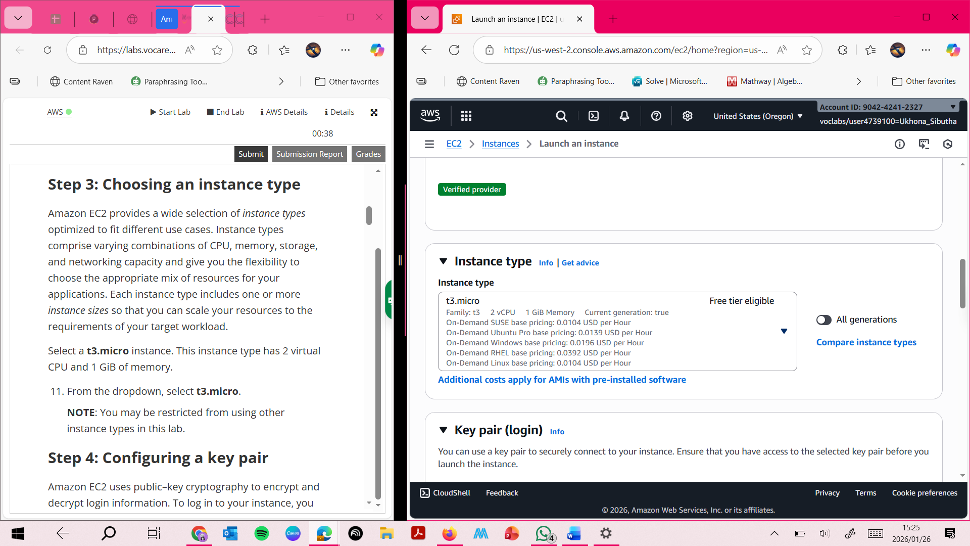

**Step 4: Confriguring a key pair**

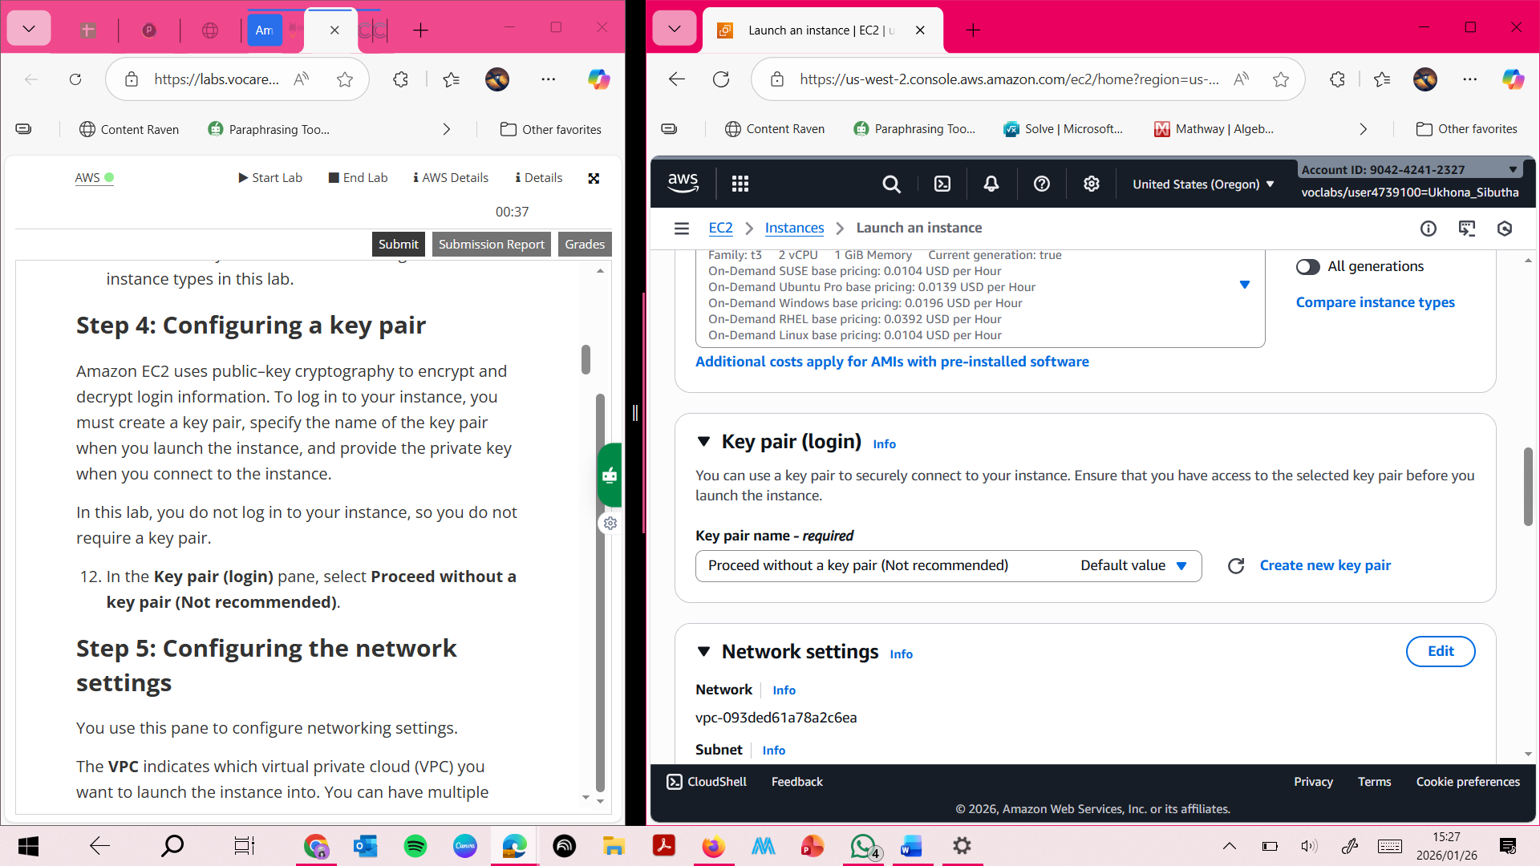

**Step 5: Configuring the network settings**

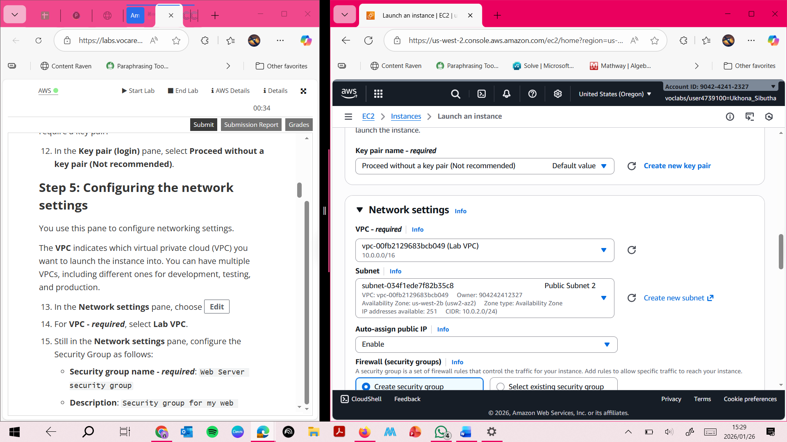

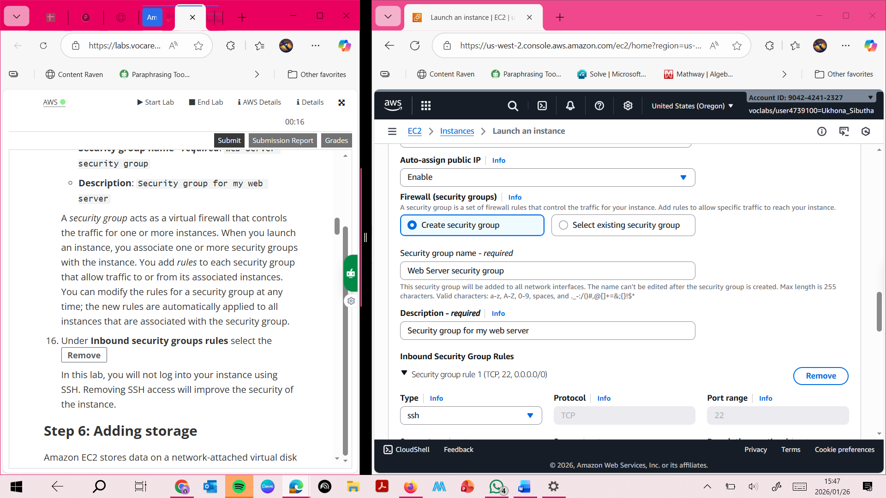

**STEP 6 ; Adding storage**

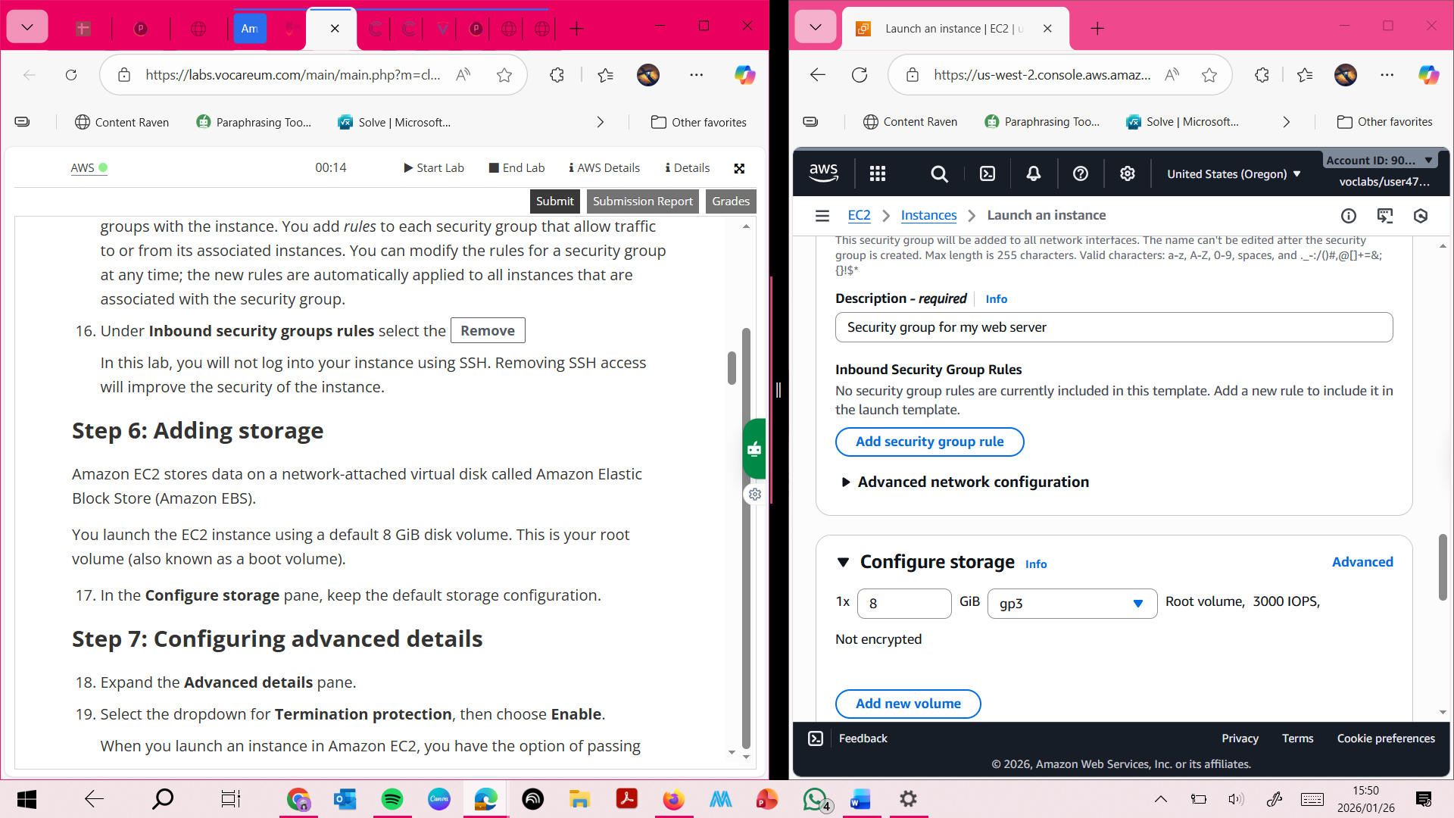

**Step 7 : Configuring advanced details**

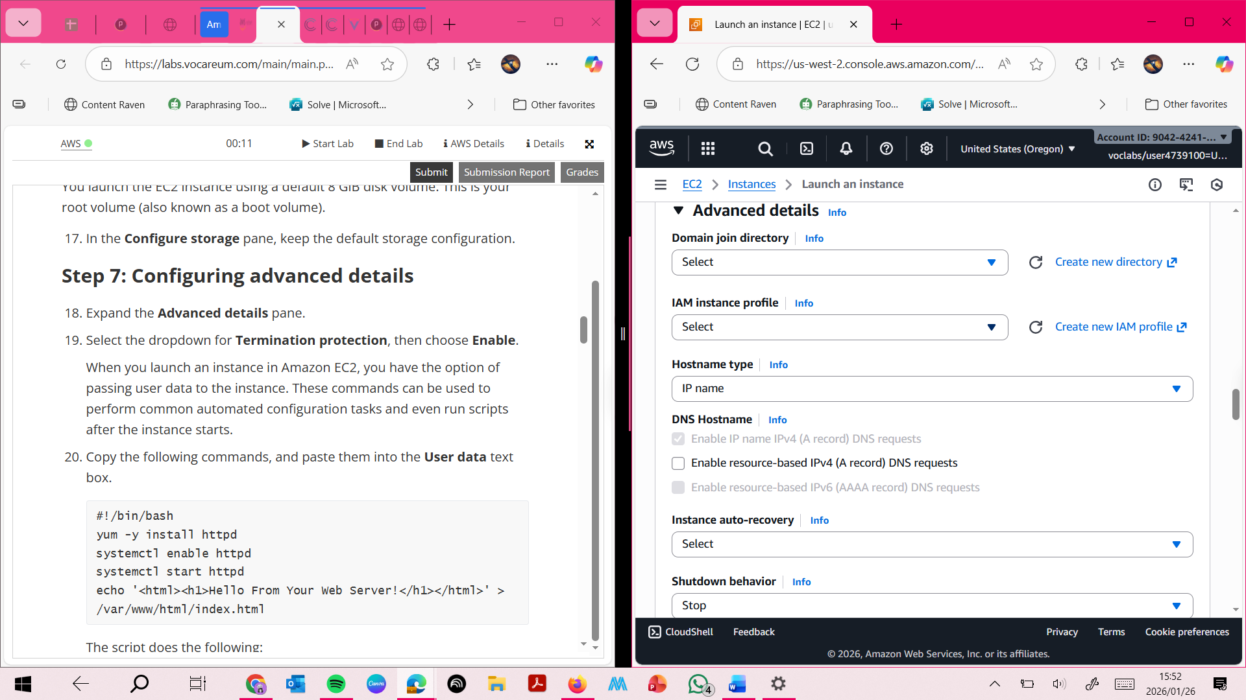

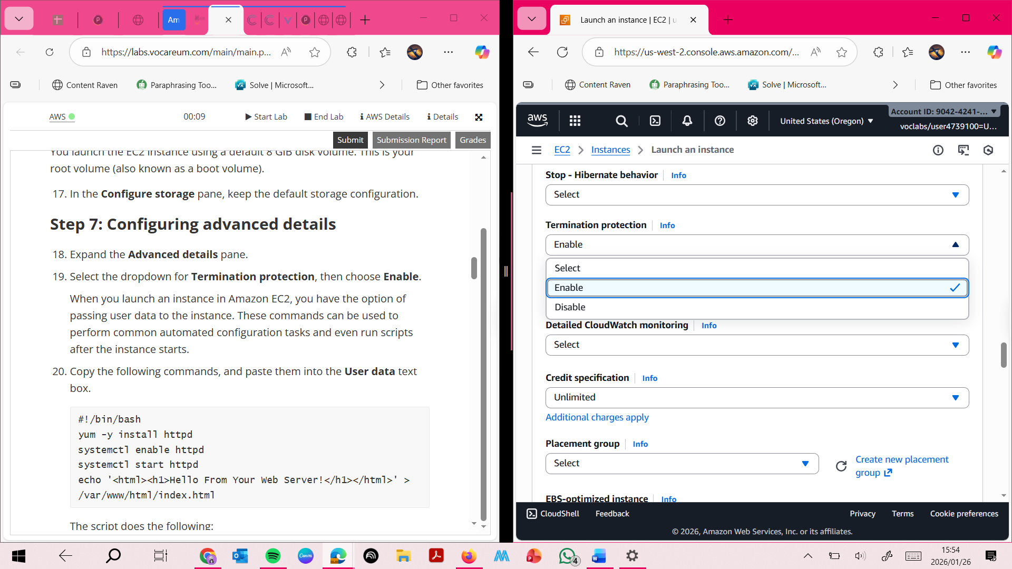

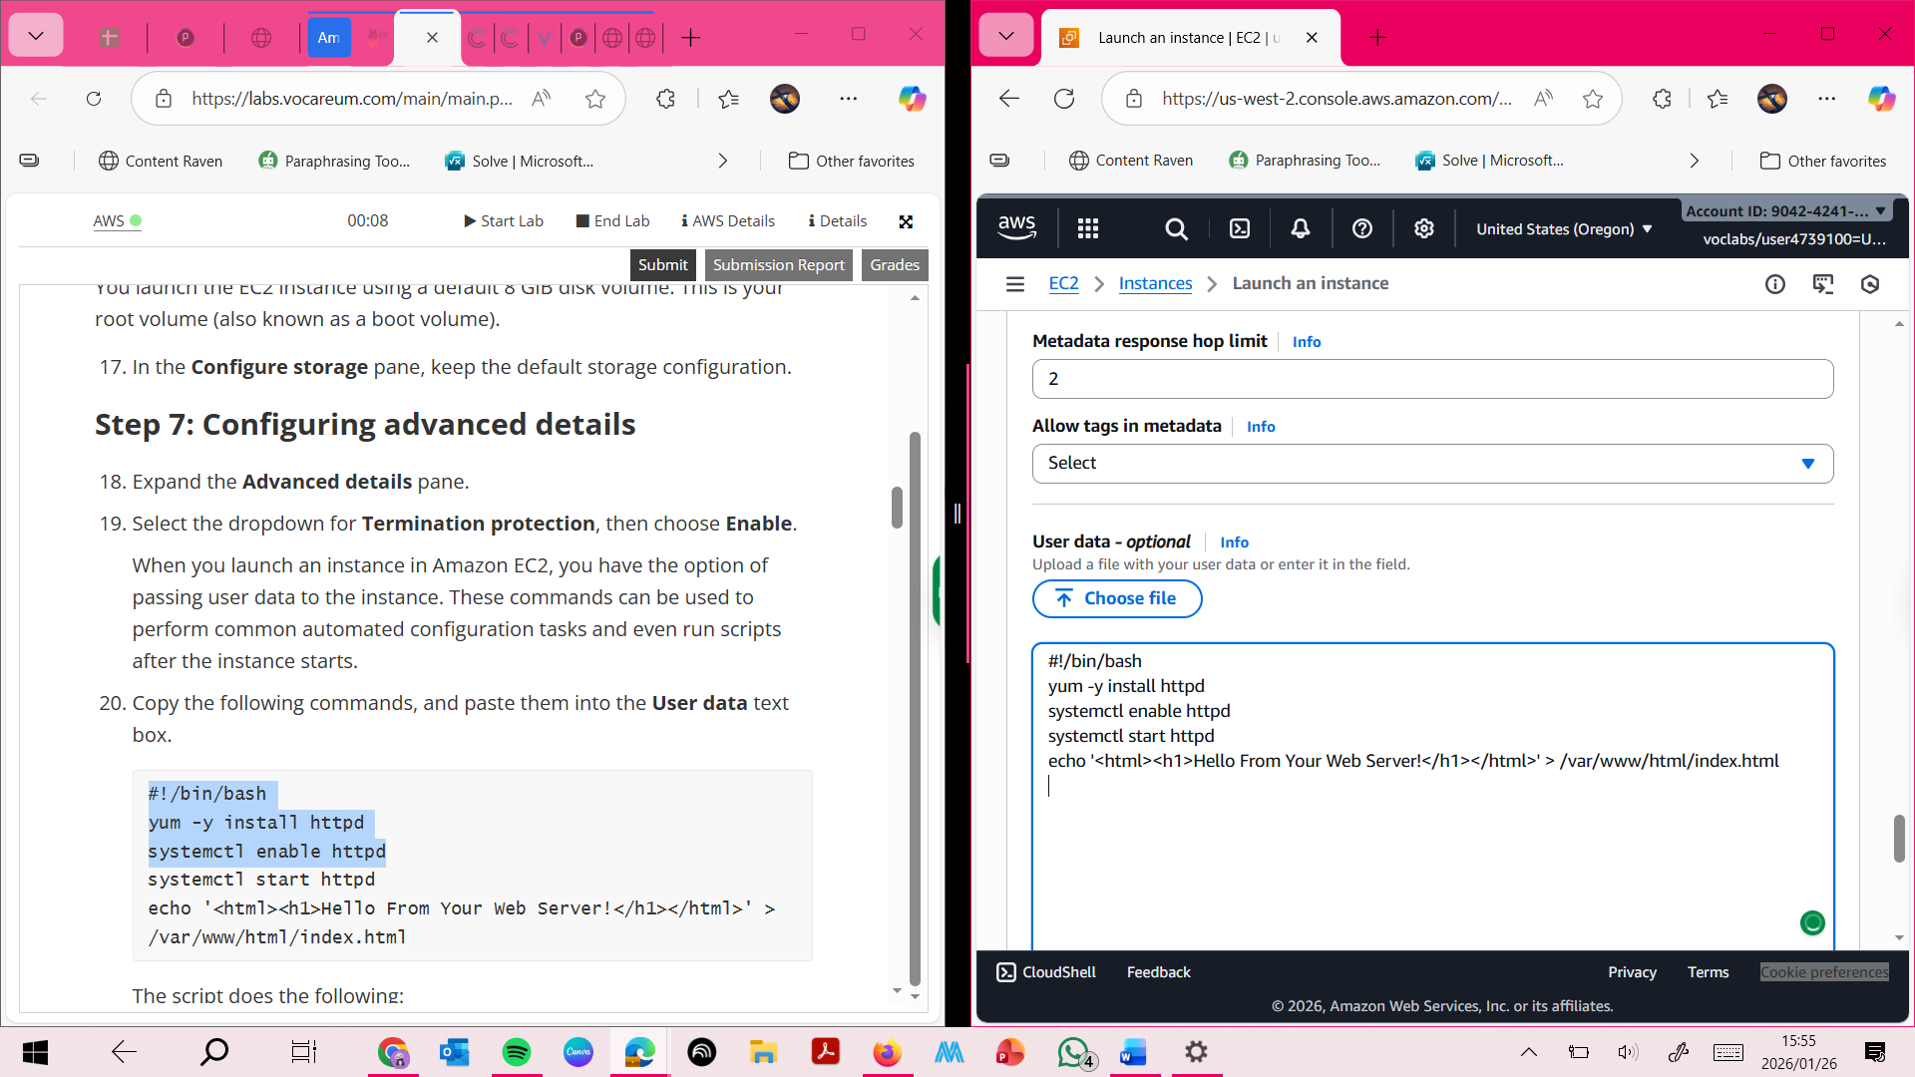

**Step 8: Launching an E2 INSTANCE**

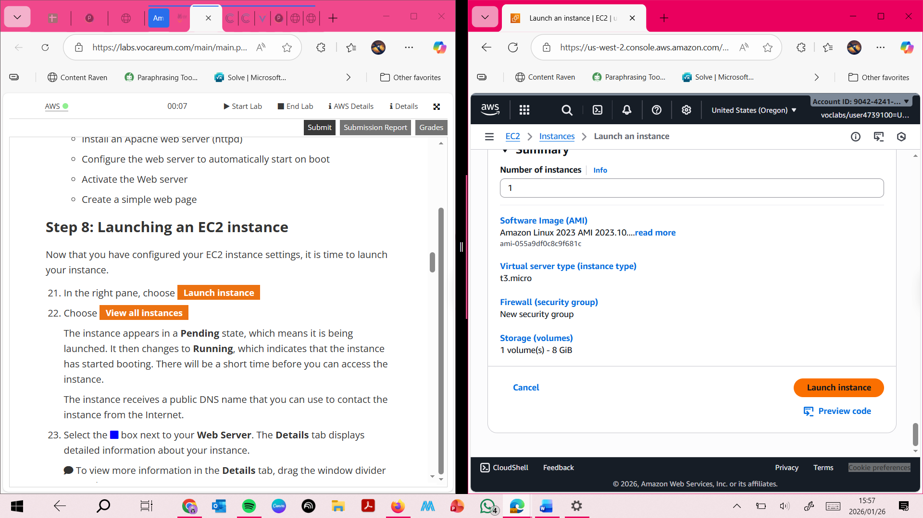

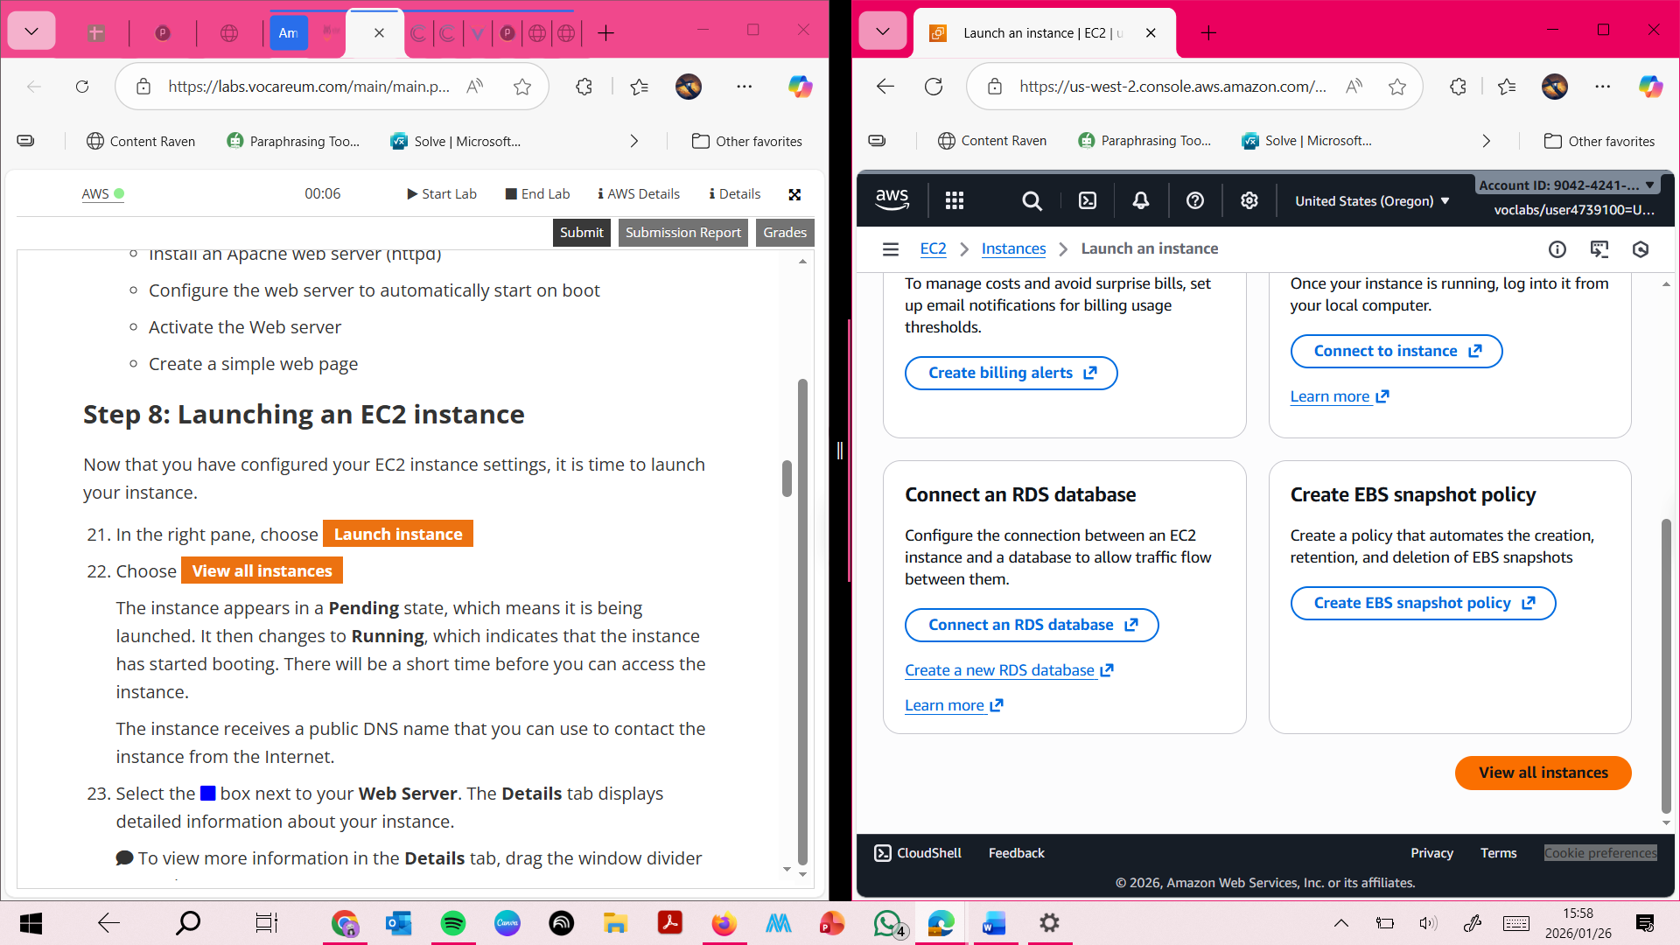

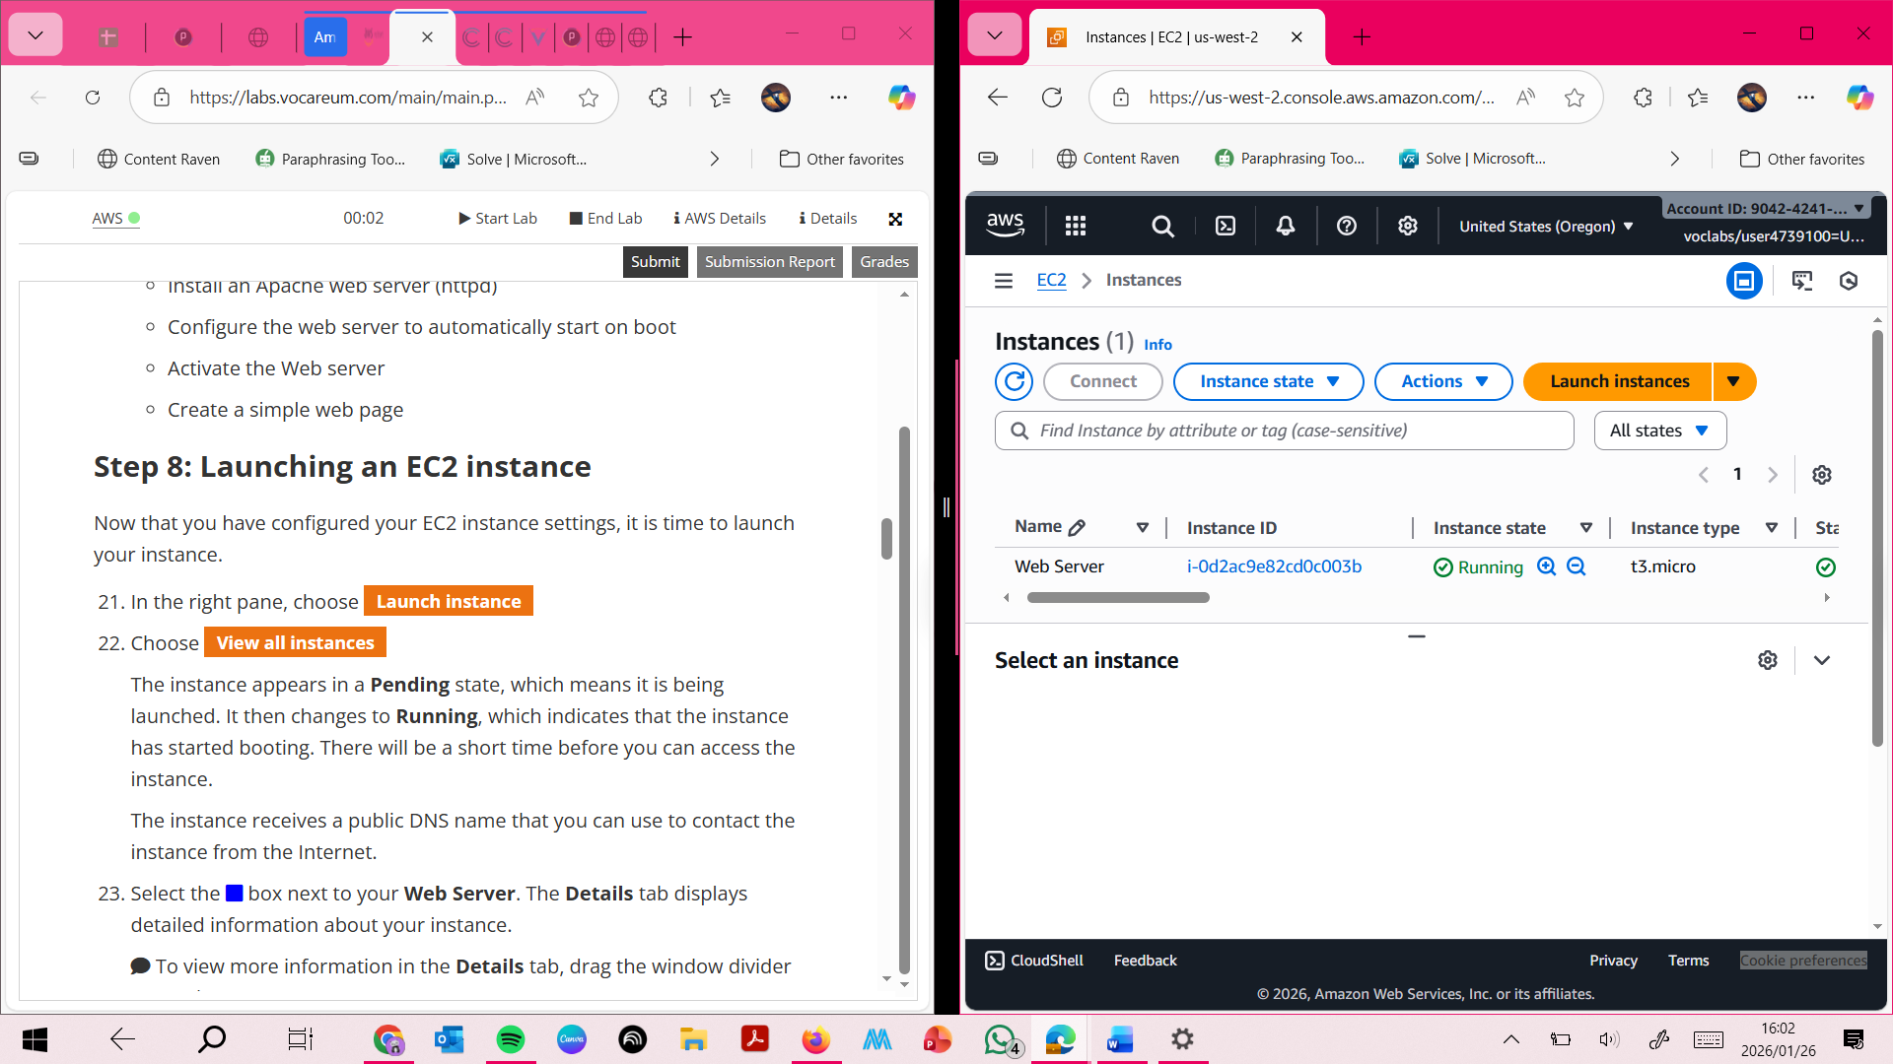

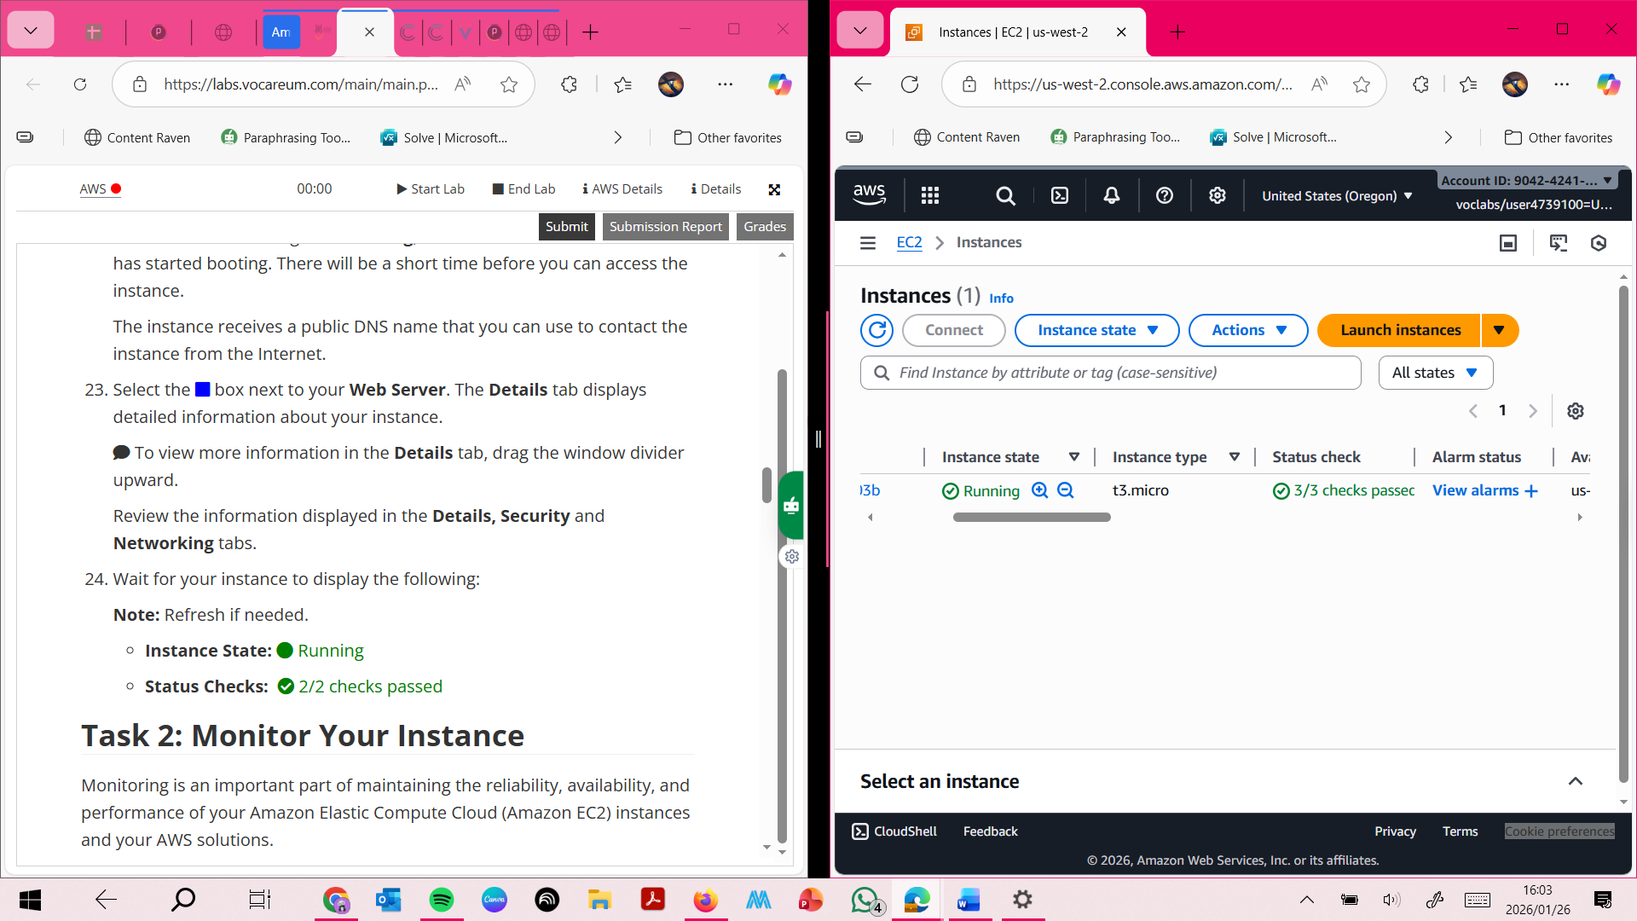

**TASK TWO :Monitoring Instance**

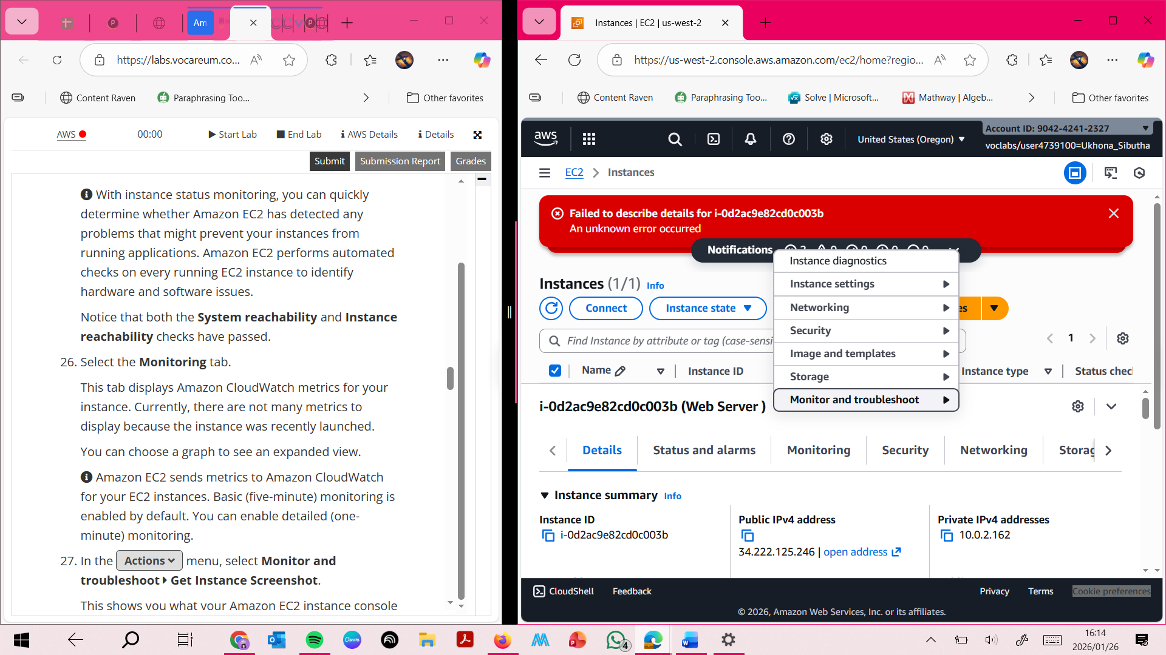

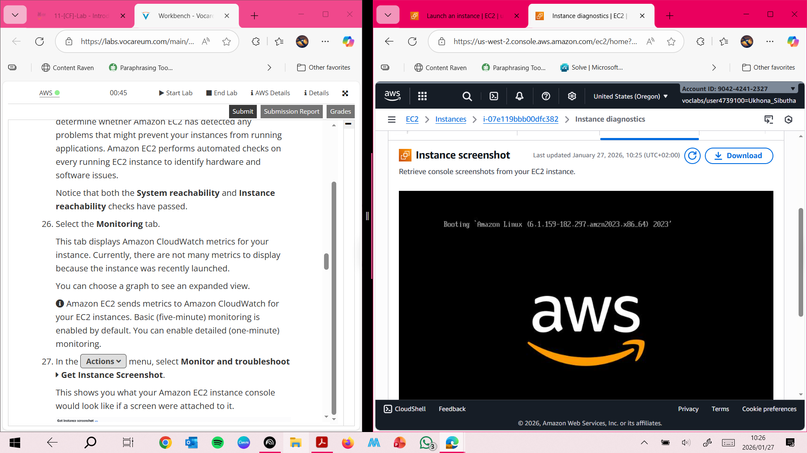

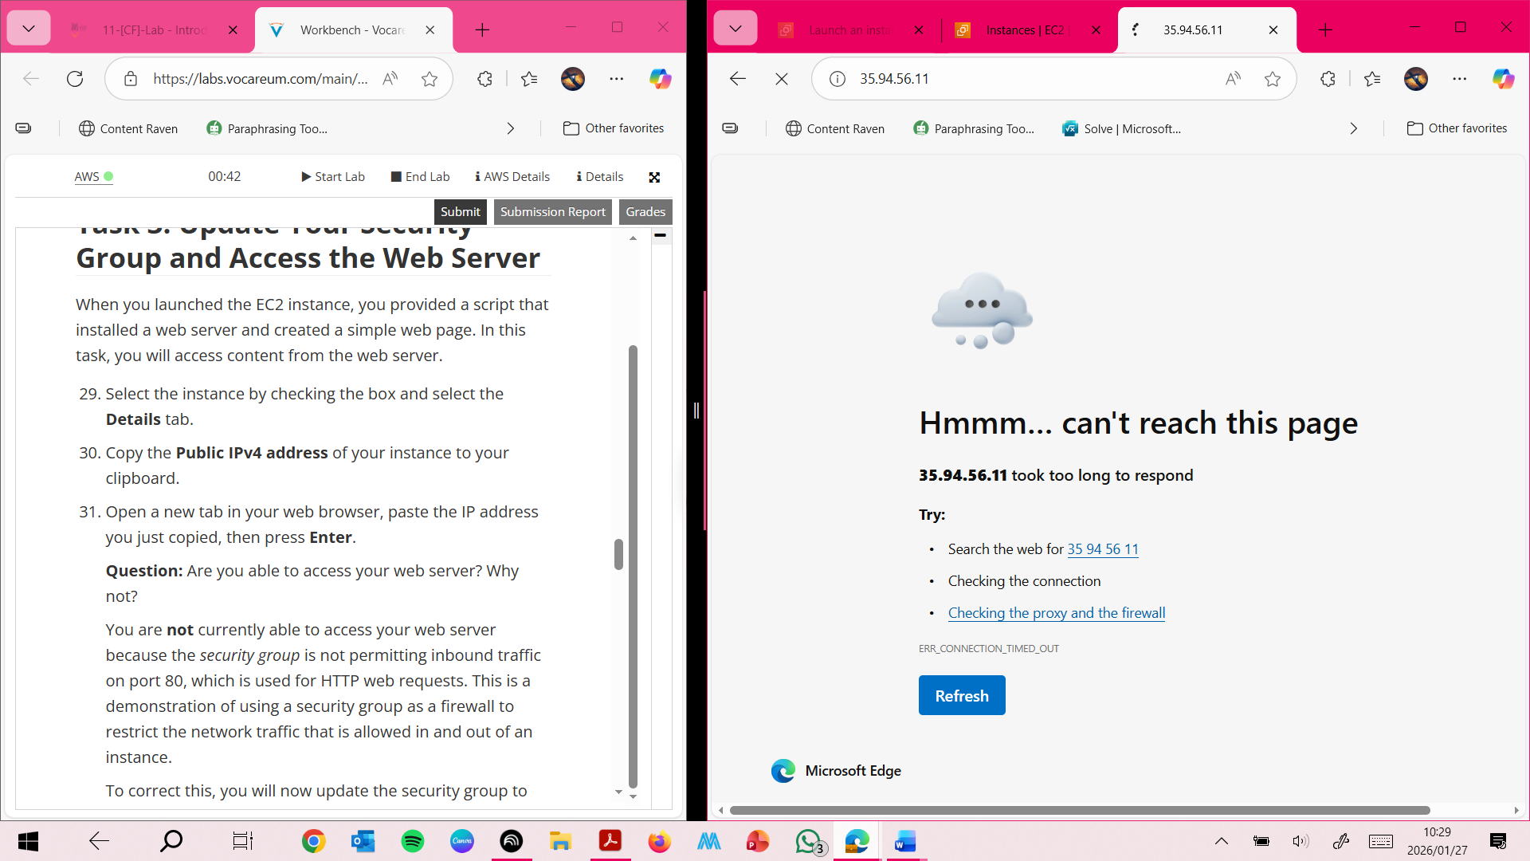

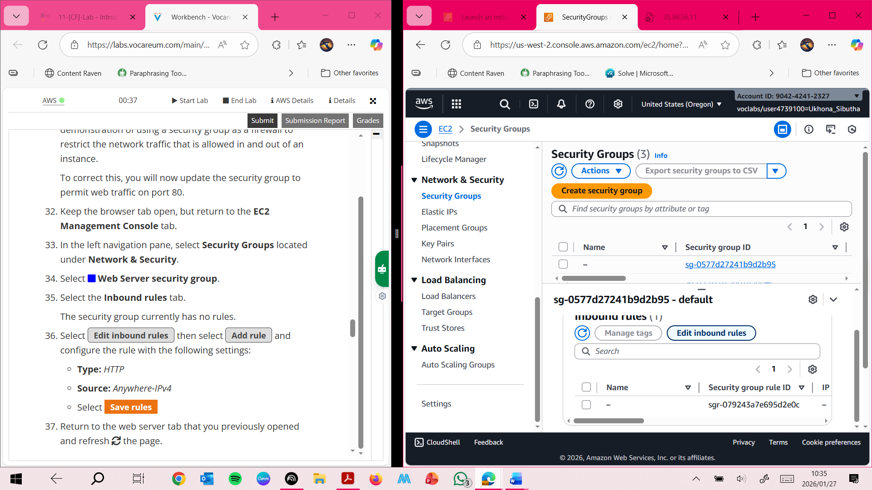

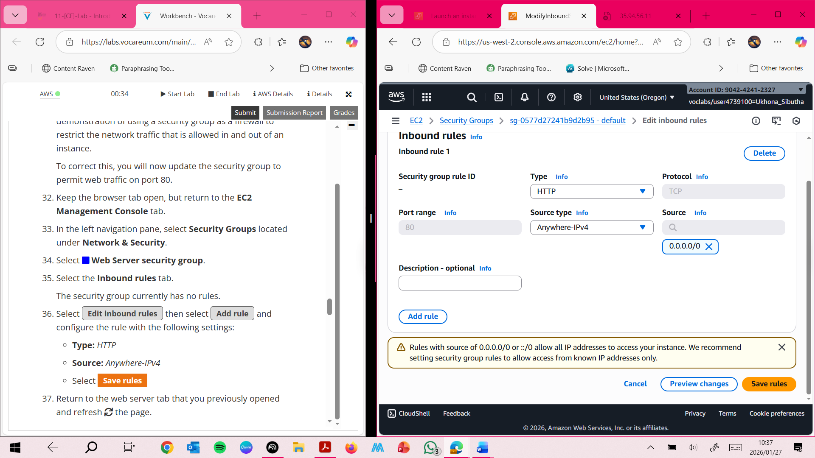

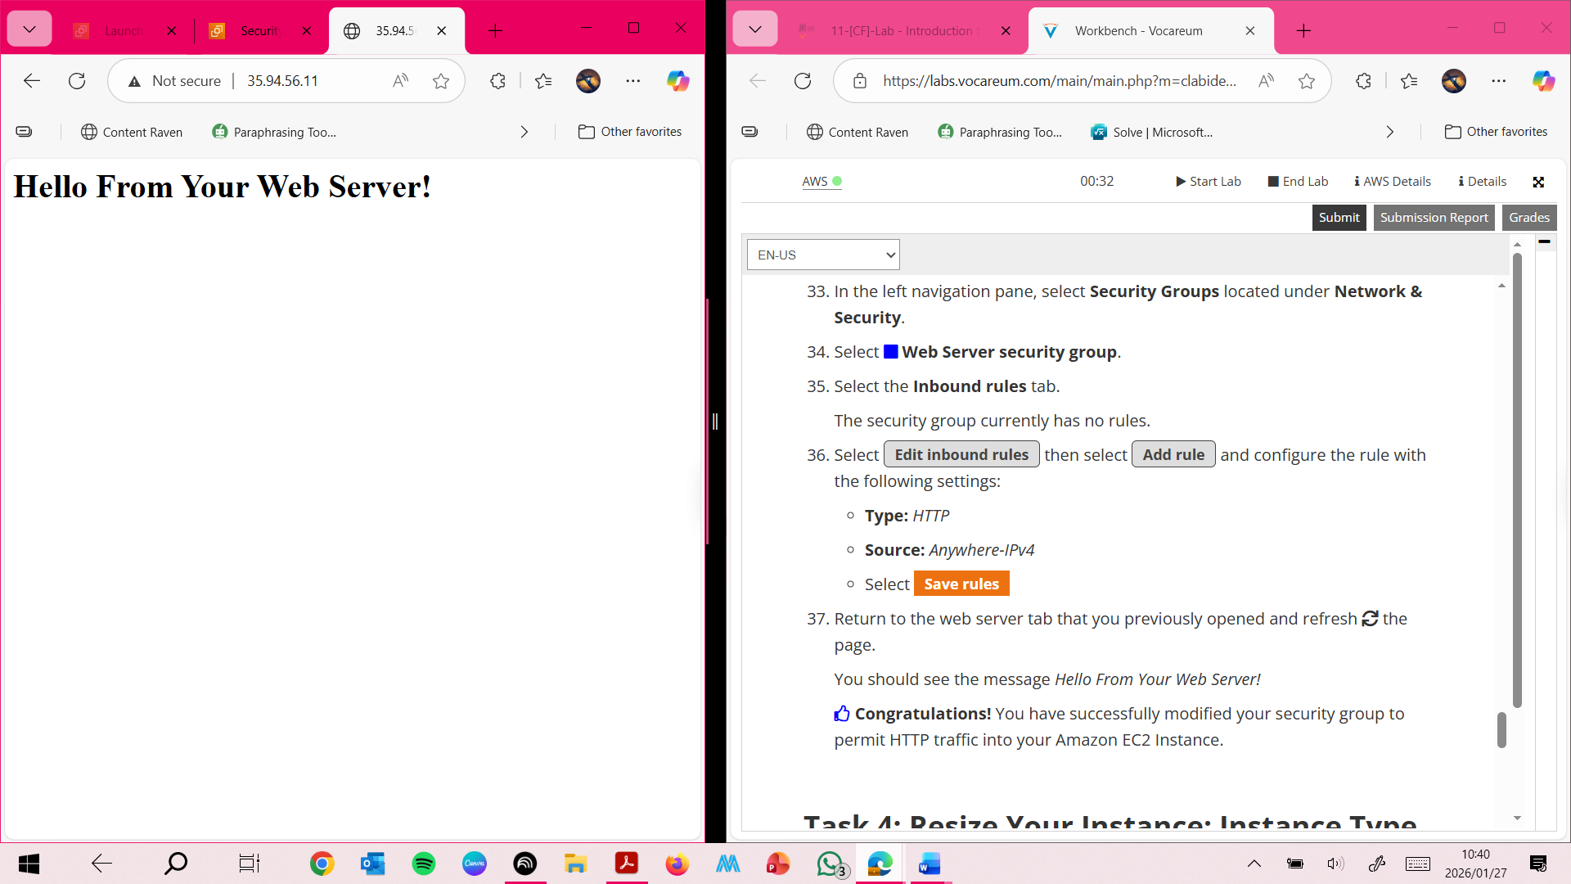

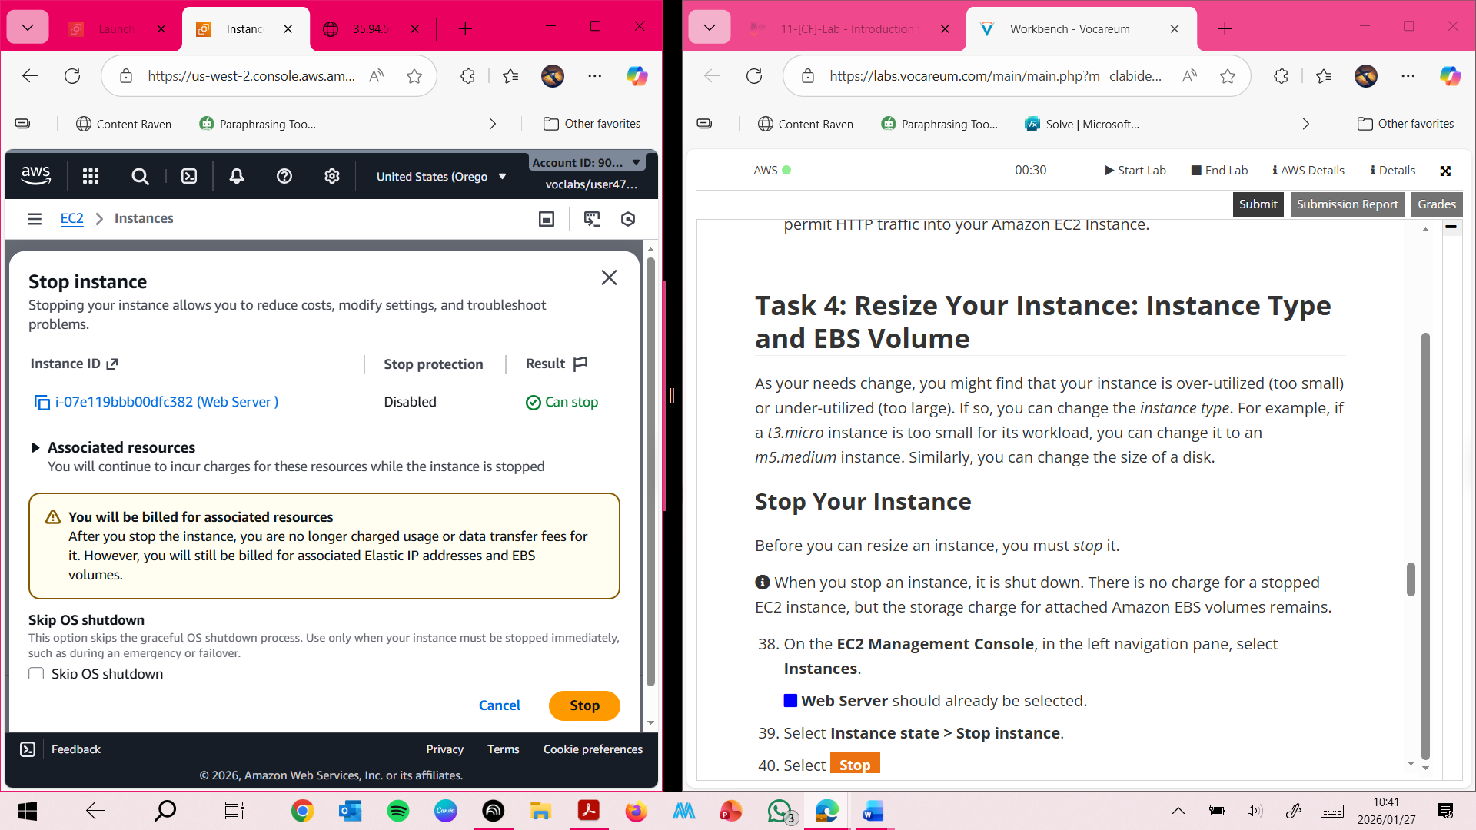

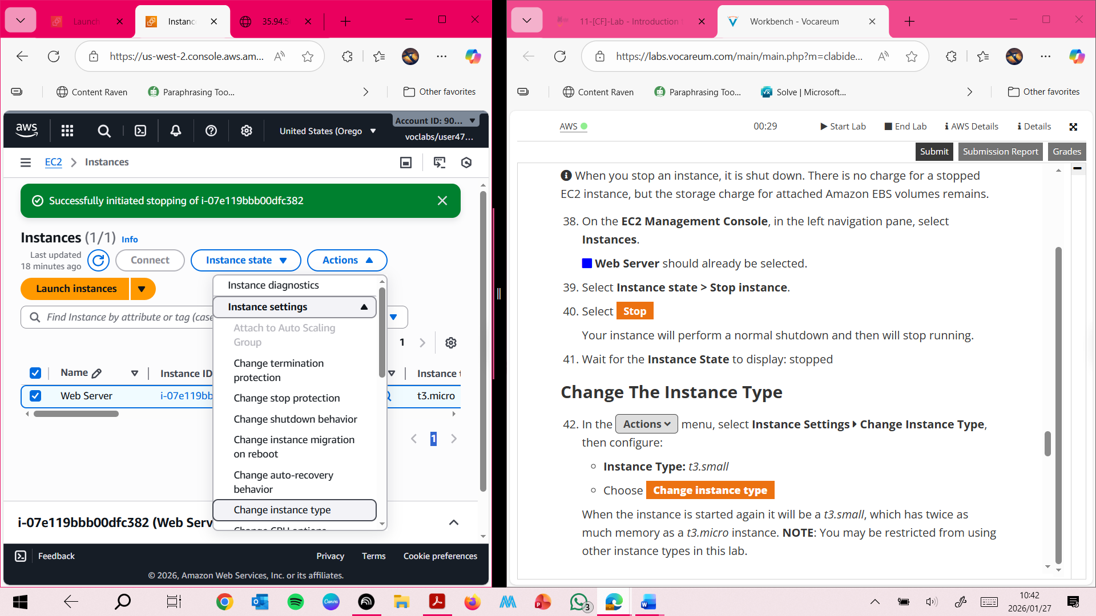

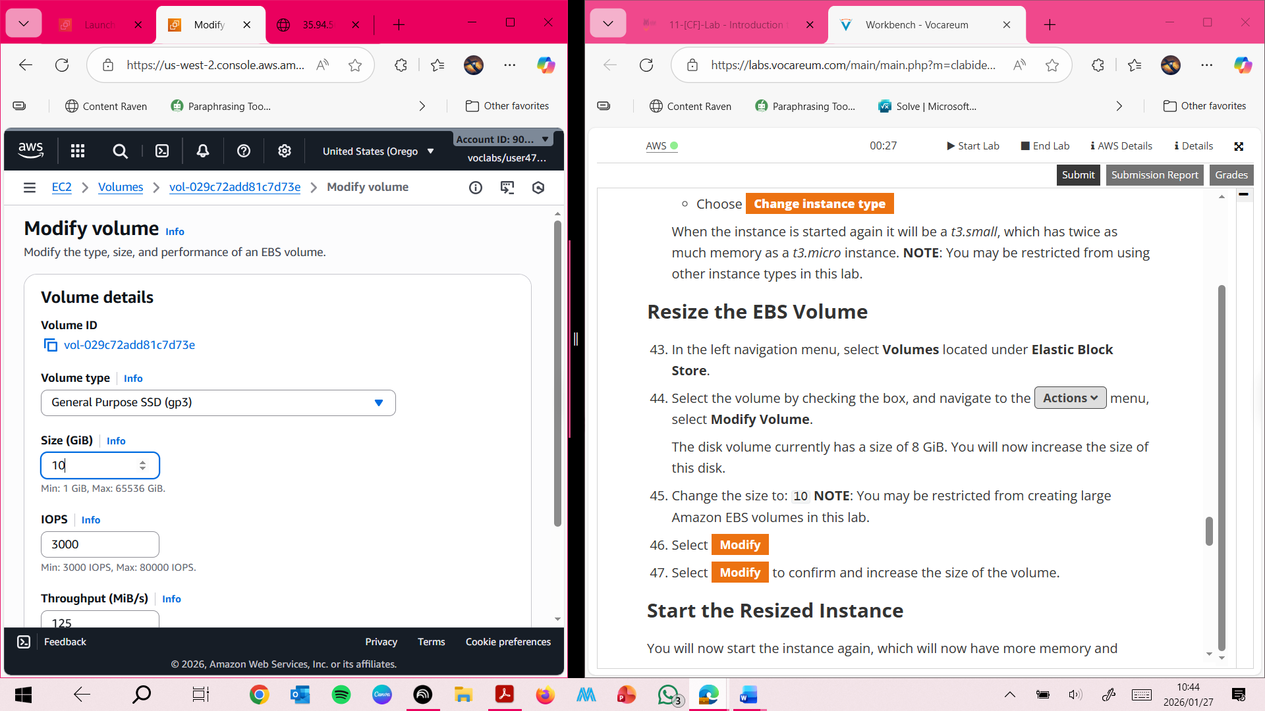

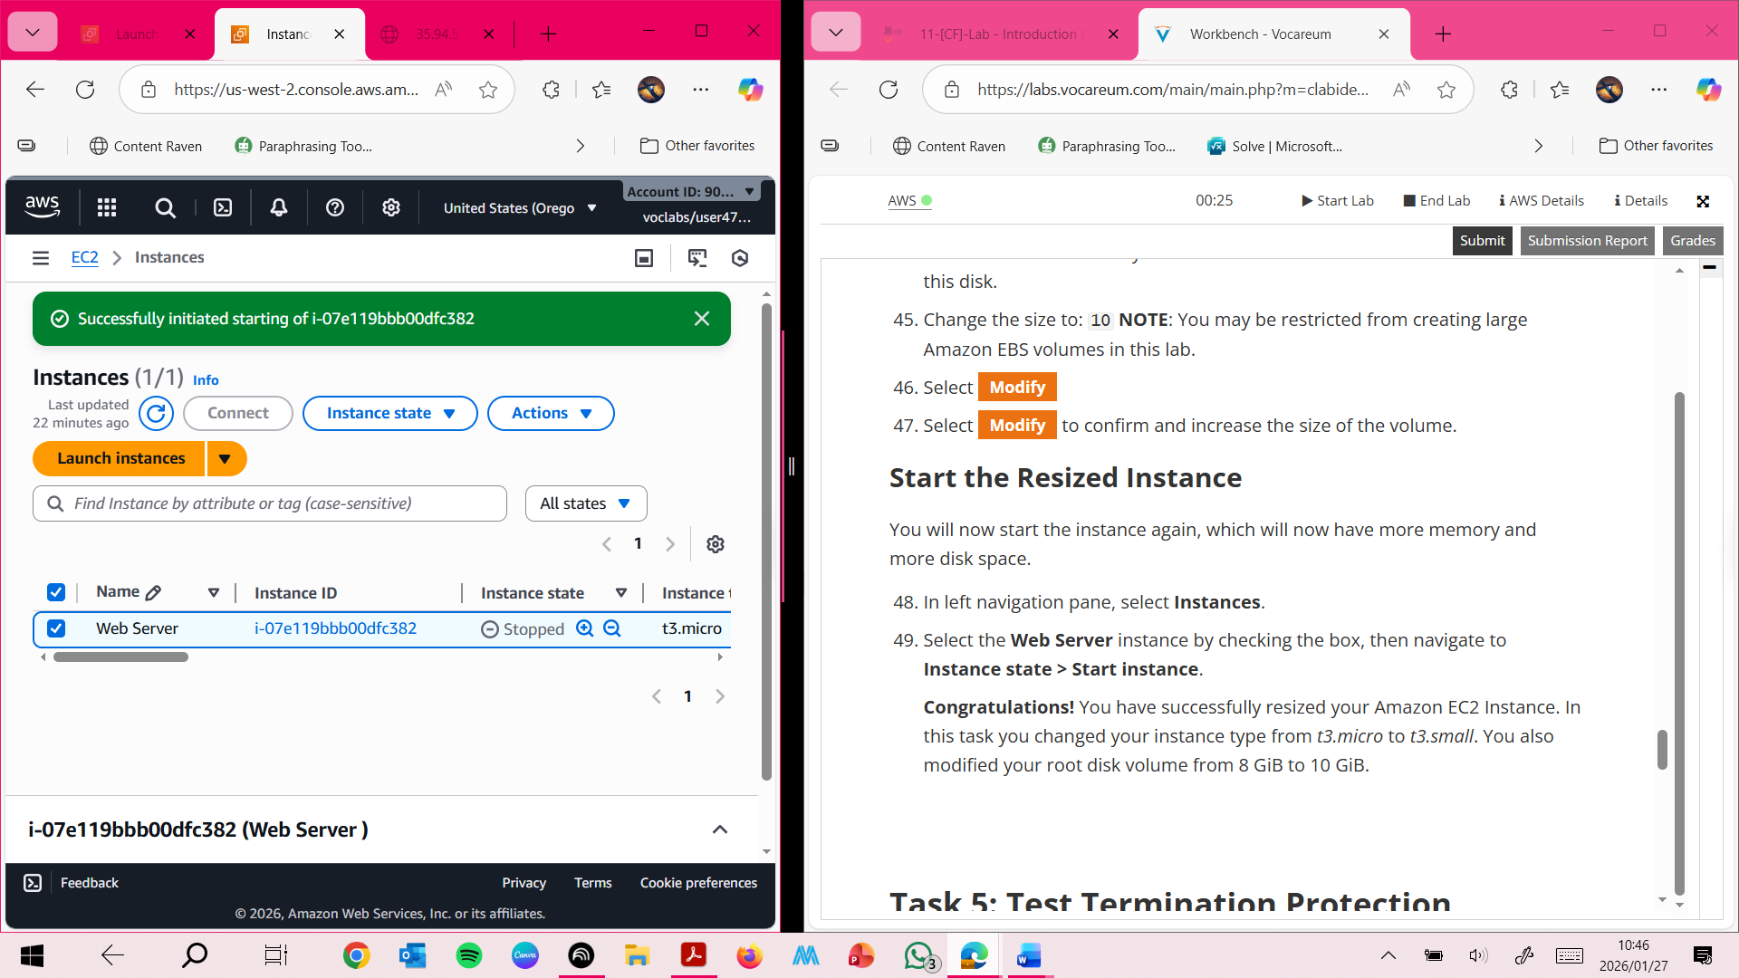

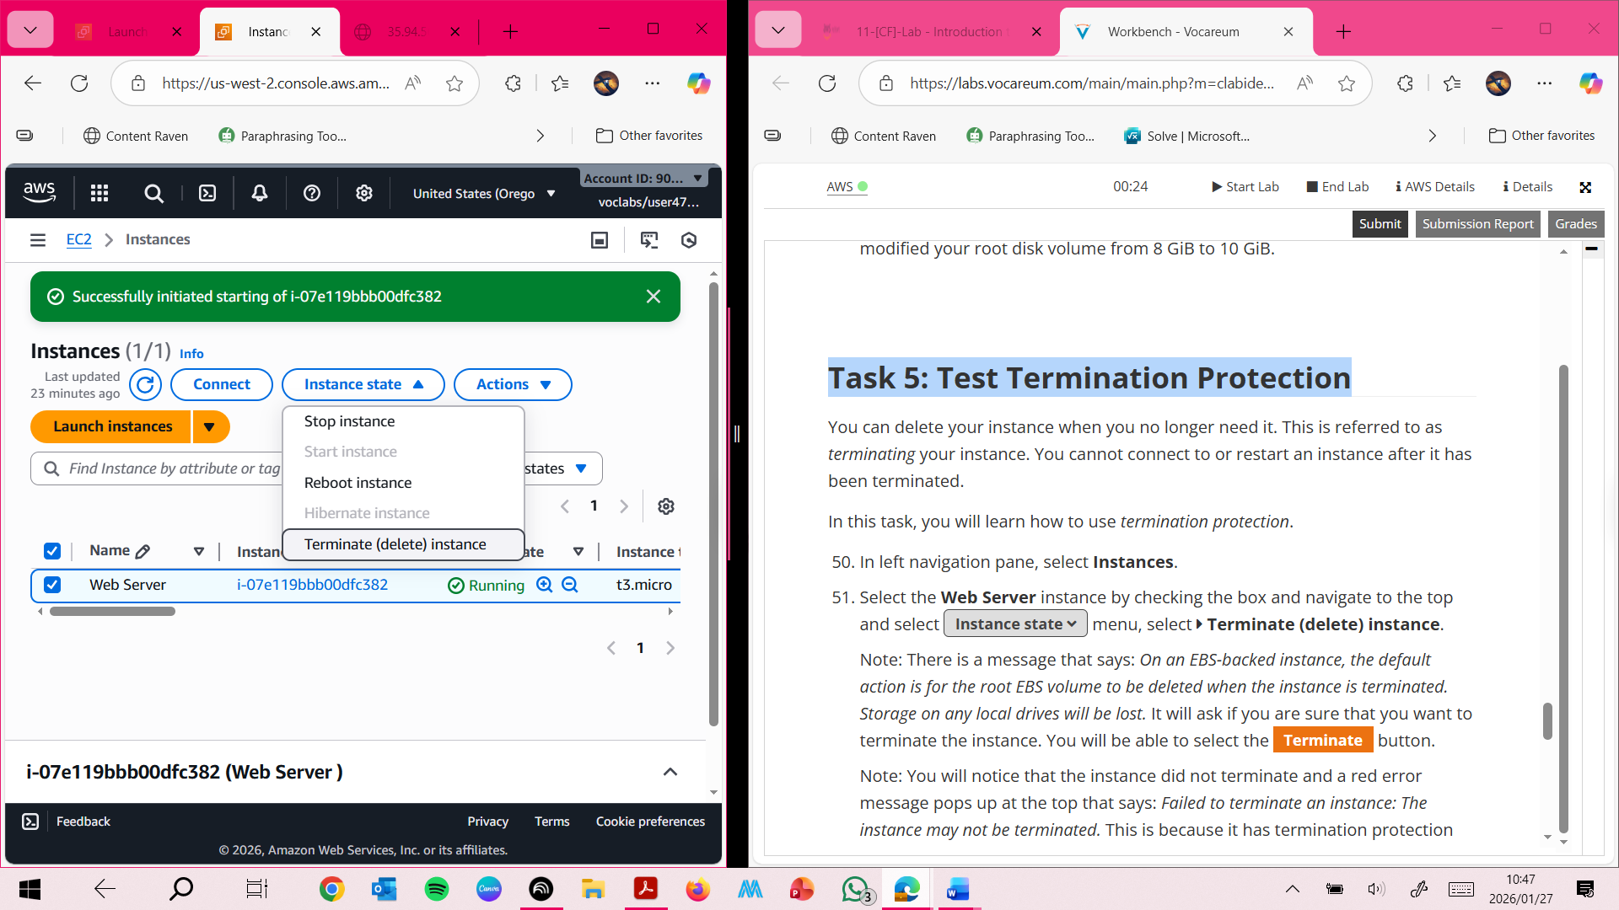

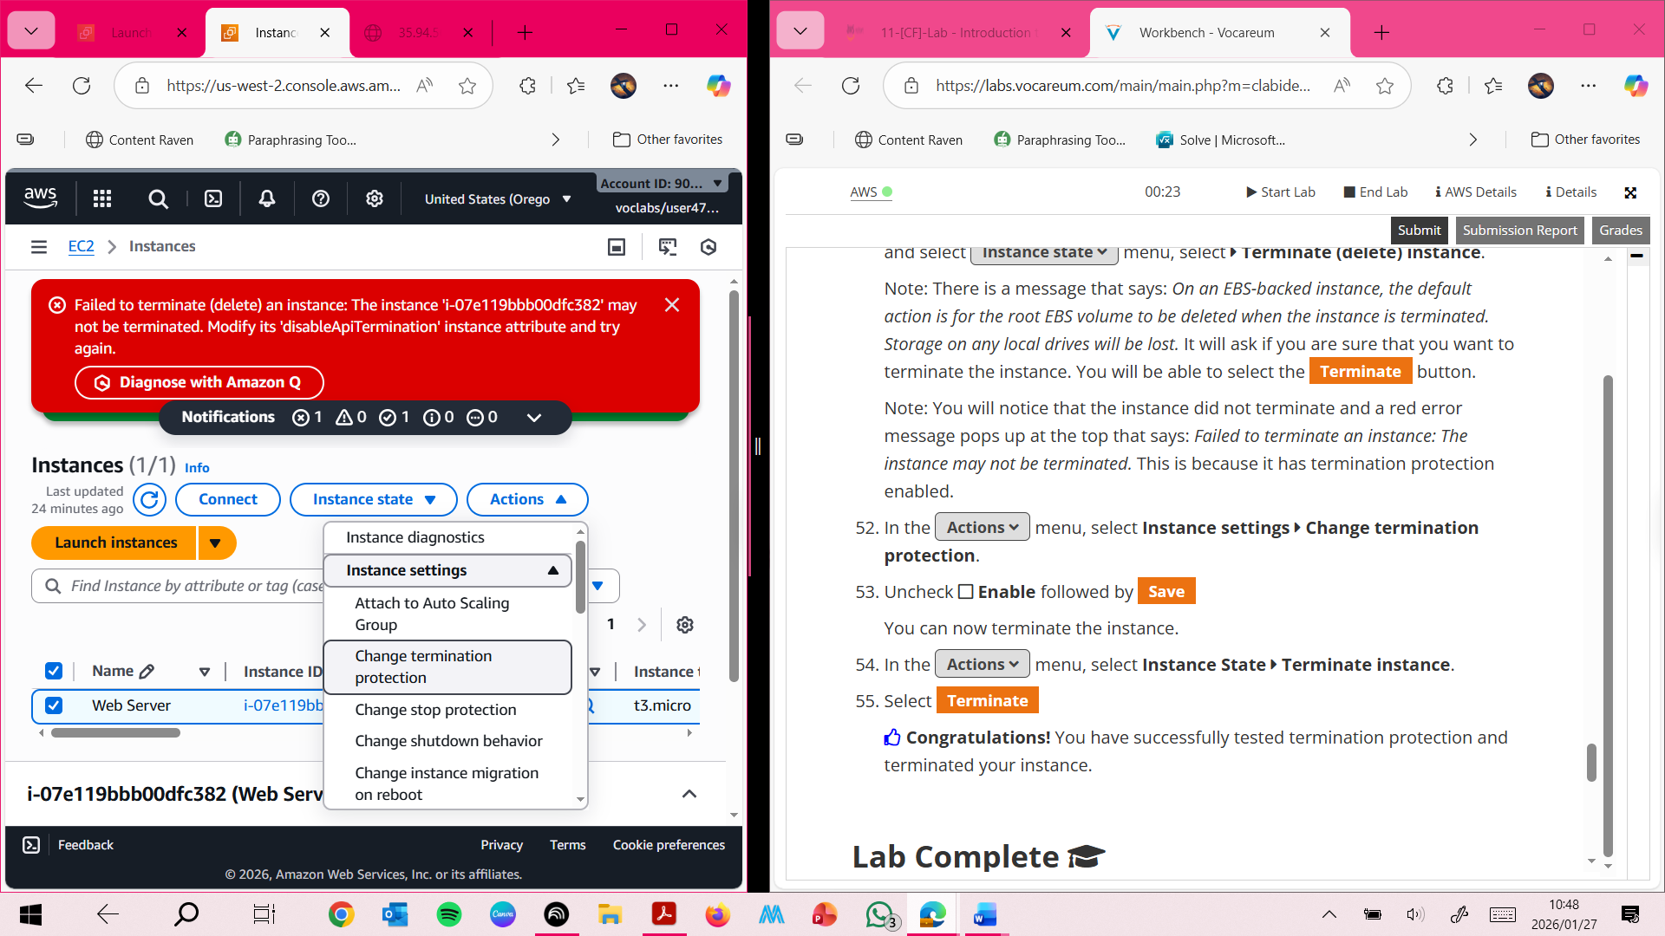

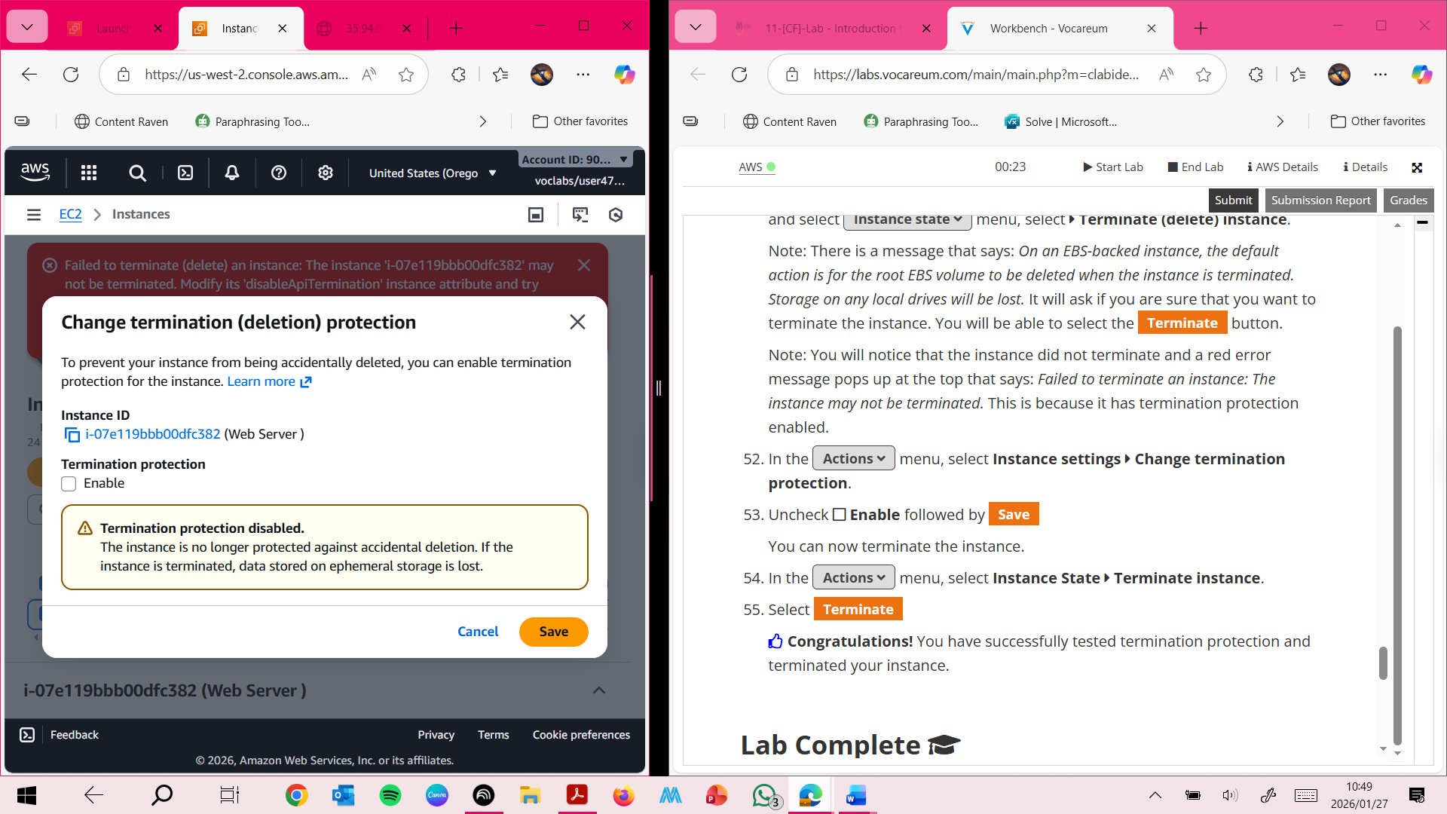

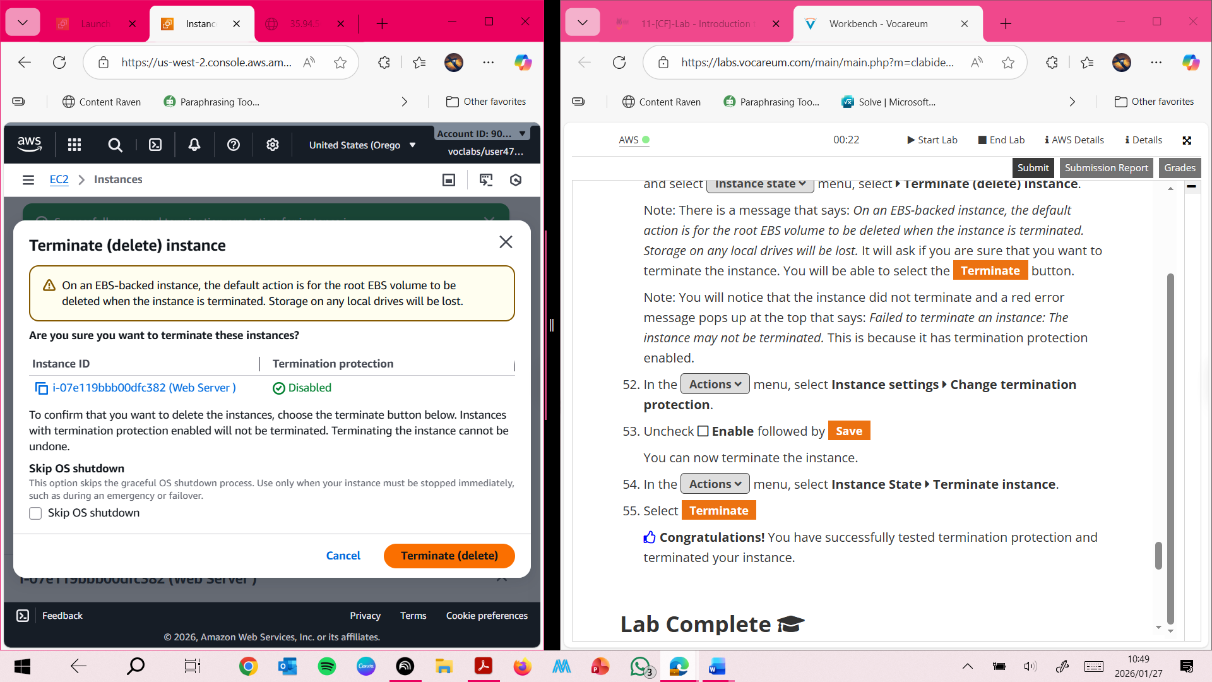

Introdu